**Peter is forgiven**

**Reading: John 21:15-17**

Jesus appeared to his disciples again. It was by the sea of Galilee.

“I’m going out to fish,” Simon Peter told them. So they went out and got into the boat. That night they didn’t catch anything.

Early in the morning, Jesus stood on the shore. But the disciples didn’t realise that it was Jesus. He called out to them, “Friends, don’t you have any fish?”

“No,” they answered.

He said, “Throw your net on the right side of the boat. There you will find some fish.” Then they did, they could not pull the net into the boat. There were too many fish.

Jesus said to them, “Bring some of the fish you have just caught. Come and have breakfast.”

When Jesus and the disciples had finished eating, Jesus spoke to Simon Peter. He asked, “Simon, son of John, do you love me more than these others do?”

“Yes, Lord,” he answered. “You know that I love you.”

Jesus said, “Feed my lambs.”

Again, Jesus asked, “Simon, son of John, do you love me?

He answered, “Yes, Lord. You know that I love you.”

Jesus said, take care of my sheep.”

Jesus spoke to him a third time. He asked, “Simon, son of John, do you love me?”

Peter felt bad because Jesus asked the third time, “Do you love me?” He answered, “Lord, you know all things. You know that I love you.”

**Thought about the reading**

When Jesus was arrested, he was taken to the house of the high priest. His special friend, Peter followed him at a distance. Some people said that they had seen Peter with Jesus. He said that he did not know Jesus. He said this three times. Then he realised what he had done – he had let Jesus down. He must have felt very sad. Would Jesus ever forgive him?

Today’s reading takes place after Jesus had risen from the dead. He met his special friends by the Sea of Galilee, and they had breakfast together. Then he talked to Peter. He asked him three times if Peter loved him. He showed Peter that he was forgiven. Jesus wanted him to be in charge of his church. He gave Peter a new start.

Sometimes we do things wrong, and we might think that we have let Jesus down. Will he be able to forgive us? Yes, he will! Jesus will always forgive us when we say that we are sorry.

**Prayer**

Lord Jesus, I am sorry that sometimes I let you down. Please forgive me.

Thank you that I know you will forgive me, and I can start again. Amen

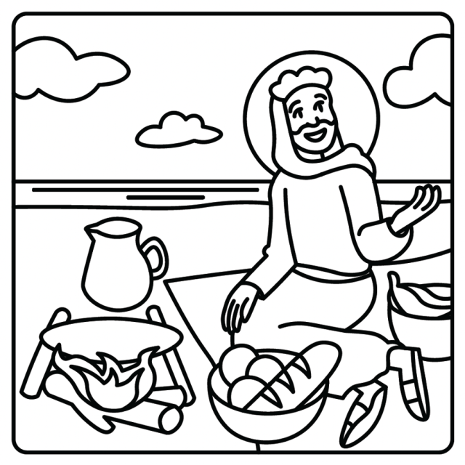

**Cambridge Causeway**

Summer 2024

Bible Study notes

**Heroes of the Bible Part 2**

1. **Peter is forgiven**

By Chrissy Cole